**Sudhakar N -SQL Assignment-1**

Create a table for students with name, age, mobile no, registration no., year of batch as columns.

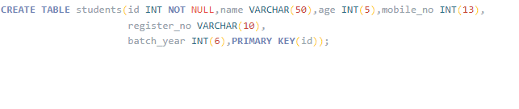

Create a table for teachers with name, domain, department as column

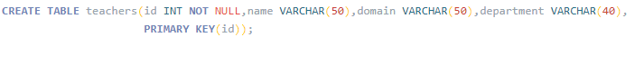

Write a query to insert 10 students data and 10 teachers data in the respective table

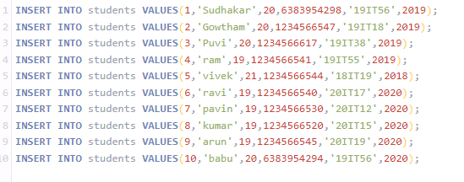

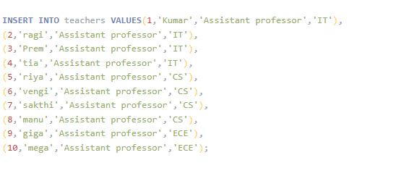

Write a query to fetch all the students from 2020 batch

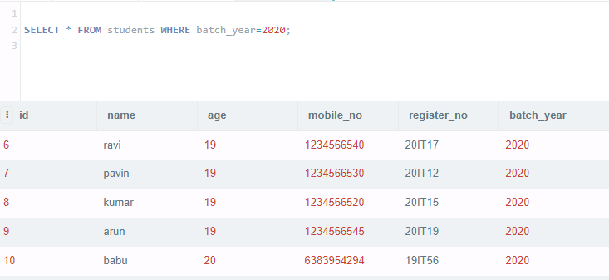

Write a query to fetch all teachers from CS department

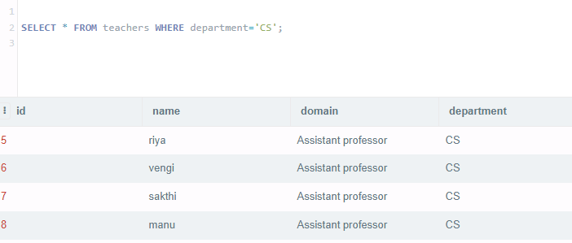

Write a query to edit at least 3 records of students

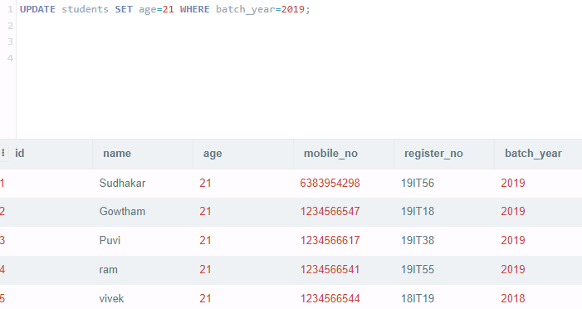

  Write a query to delete 2 records from teacher’s table

